# NM DATA ANALYTICS ASSIGNMENT 3 - House Price dataset of India

DONE BY Jacinth Susanna S

Importing the necessary libraries for EDA and data preprocessing

import pandas as pd import numpy as np import matplotlib. pyplot as PIt import seaborn as sns import folium from scipy import stats

# Converting csv file into dataframe



In 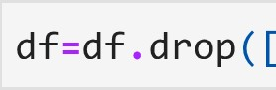 'Date' ] , axis-I)

Out[5] :

number number number condition grade number of living lot waterfront Built Renovatio

id of of of of the of the bedrooms bathrooms area area present house house Year Yee floors views

o 6762810145 5 2.50 3650 9050 2.0 4 5 101921

1. 6762810635 4 2.50 2920 4000 1.5 5 81909
2. 6762810998 5 2.75 2910 9480 1.5 3 81939
3. 6762812605 4 2.50 3310 42998 2.0 3 92001
4. 6762812919 3 2.00 2710 4500 1.5 4 81929
5. 6762830250 2 1.50 1556 20000 1.0 4 71957
6. 6762830339 3 2.00 1680 7000 1.5 4 71968
7. 6762830618 2 1.00 1070 6120 1.0 3 61962
8. 6762830709 4 1.00 1030 6621 1.0 4 61955
9. 6762831463 3 1.00 900 4770 1.0 3 61969 200
10. rows x 22 columns



df.head()

Out

number number number condition grade number of living lot waterfront Built Renovation 

id of of of of the of the bathrooms area area present Year Year bedrooms floors views house house

o 6762810145 5 2.50 3650 9050 2.0 4 5 10  1921

1. 6762810635 4 2.50 2920 4000 1.5 0 5 81909
2. 6762810998 5 2.75 2910 9480 1.5 3 81939
3. 6762812605 4 2.50 3310 42998 2.0 0 3 92001 o 1:
4. 6762812919 3 2.00 2710 4500 1.5 4 8  1929
5. rows x 22 columns



## df.tail()

Out [7] :

number number number condition grade number of living lot waterfront Built Renovatio

id of of of of the of the bedrooms bathrooms area area present house house Year Yee floors views

1. 6762830250 2 1.5 1556 20000 1.0 4 71957



1. 6762830339 3 2.0 1680 7000 1.5 4 71968
2. 6762830618 2 1.0 1070 6120 1.0 3 61962
3. 6762830709 4 1.0 1030 6621 1.0 4 61955
4. 6762831463 3 1.0 900 4770 1.0 3 61969 200

5 rows x 22 columns



# Checking for null and duplicated values

|  |  |  |  |  |  |
| --- | --- | --- | --- | --- | --- |
| In [8] : | | | df.isna() .sum() | |  |
| Out [8] : | | | id | | 0 |
|  | | | number of bedrooms | | 0 |
|  | |  |  |  | | --- | --- | --- | | number of bathrooms living area lot area number of floors waterfront present number of views condition of the house grade of the house  Area of the house(excluding  Area of the basement Built Year  Renovation Year  Postal Code  L attitude Longitude living area renov lot area renov  Number of schools nearby Distance from the airport Price dtype: int64 | basement) | 0  0  0  0  0  0  0  0  0  0  0  0  0  0  0  0  0  0  0  0 | | df.duplicated() . sum() |  |  | | | | | |
| Out[9] : | | | |  |
| In [10] : | | | | df.info() |

<class 'pandas. core. frame. DataFrame' > Rangelndex: 14620 entries, 0 to 14619 Data columns (total 22 columns) :

 Column Non-Null Count Dtype



|  |  |  |  |  |  |
| --- | --- | --- | --- | --- | --- |
| e | id |  | 14620 | non-null | int64 |
| 1 | number of bedrooms |  | 14620 | non-null | int64 |
| 2 | number of bathrooms |  | 14620 | non-null | float64 |
| 3 | living area |  | 14620 | non-null | int64 |
| 4 | lot area |  | 14620 | non-null | int64 |
| 5 | number of floors |  | 14620 | non-null | float64 |
| 6 | waterfront present |  | 14620 | non-null | int64 |
| 7 | number of views |  | 14620 | non-null | int64 |
| 8 | condition of the house |  | 14620 | non-null | int64 |
| 9 | grade of the house |  | 14620 | non-null | int64 |
| 10 | Area of the house(excluding | basement) | 14620 | non-null | int64 |
| 11 | Area of the basement |  | 14620 | non-null | int64 |
| 12 | Built Year |  | 14620 | non-null | int64 |
| 13 | Renovation Year |  | 14620 | non-null | int64 |
| 14 | Postal Code |  | 14620 | non-null | int64 |
| 15 | L attitude |  | 14620 | non-null | float64 |
| 16 | Longitude |  | 14620 | non-null | float64 |
| 17 | living area renov |  | 14620 | non-null | int64 |
| 18 | lot area renov |  | 14620 | non-null | int64 |
| 19 | Number of schools nearby |  | 14620 | non-null | int64 |
| 20 | Distance from the airport |  | 14620 | non-null | int64 |
| 21 | Price |  | 14620 | non-null | int64 |

dtypes: float64(4), int64(18) memory usage: 2.5 MB

[11] : df.describe()

Out[ll] :

|  |  |  |  |  |  |  |  |  |
| --- | --- | --- | --- | --- | --- | --- | --- | --- |
| id | number of | number of | living area | lot area | number of | waterfront | number of | condi |
|  | bedrooms | bathrooms |  |  | floors | present | views | the |

|  |  |  |  |  |  |  |  |  |  |
| --- | --- | --- | --- | --- | --- | --- | --- | --- | --- |
| count | 1.462000e+04 | 14620.000000 | 14620.000000 | 14620.000000 | 1.462000e+04 | 14620.000000 | 14620.000000 | 14620.000000 | 14620. |
| mean | 6.762821e+09 | 3.379343 | 2.129583 | 2098.262996 | 1.509328e+04 | 1.502360 | 0.007661 | 0.233105 | 3. |
| std | 6.237575e+03 | 0.938719 | 0.769934 | 928.275721 | 3.791962e+04 | 0.540239 | 0.087193 | 0.766259 | o. |
| min | 6.762810e+09 | 1.000000 | 0.500000 | 370.000000 | 5.200000e+02 | 1.000000 | 0.000000 | 0.000000 | 1. |
| 25% | 6.762815e+09 | 3.000000 | 1.750000 | 1440.000000 | 5.010750e+03 | 1.000000 | 0.000000 | 0.000000 | 3. |
| 50% | 6.762821e+09 | 3.000000 | 2.250000 | 1930.000000 | 7.620000e+03 | 1.500000 | 0.000000 | 0.000000 | 3. |
| 75% | 6.762826e+09 | 4.000000 | 2.500000 | 2570.000000 | 1.080000e+04 | 2.000000 | 0.000000 | 0.000000 | 4. |
| max | 6.762832e+09 | 33.000000 | 8.000000 | 13540.000000 | 1.074218e+06 | 3.500000 | 1.000000 | 4.000000 | 5. |

8 rows x 22 columns



UNIVARIATE ANALYSIS

# Checking for outliers

In [12] : sns.boxplot(df[ ' number of bedrooms ' ] )

Out [12] : <AxesSubp10t : >

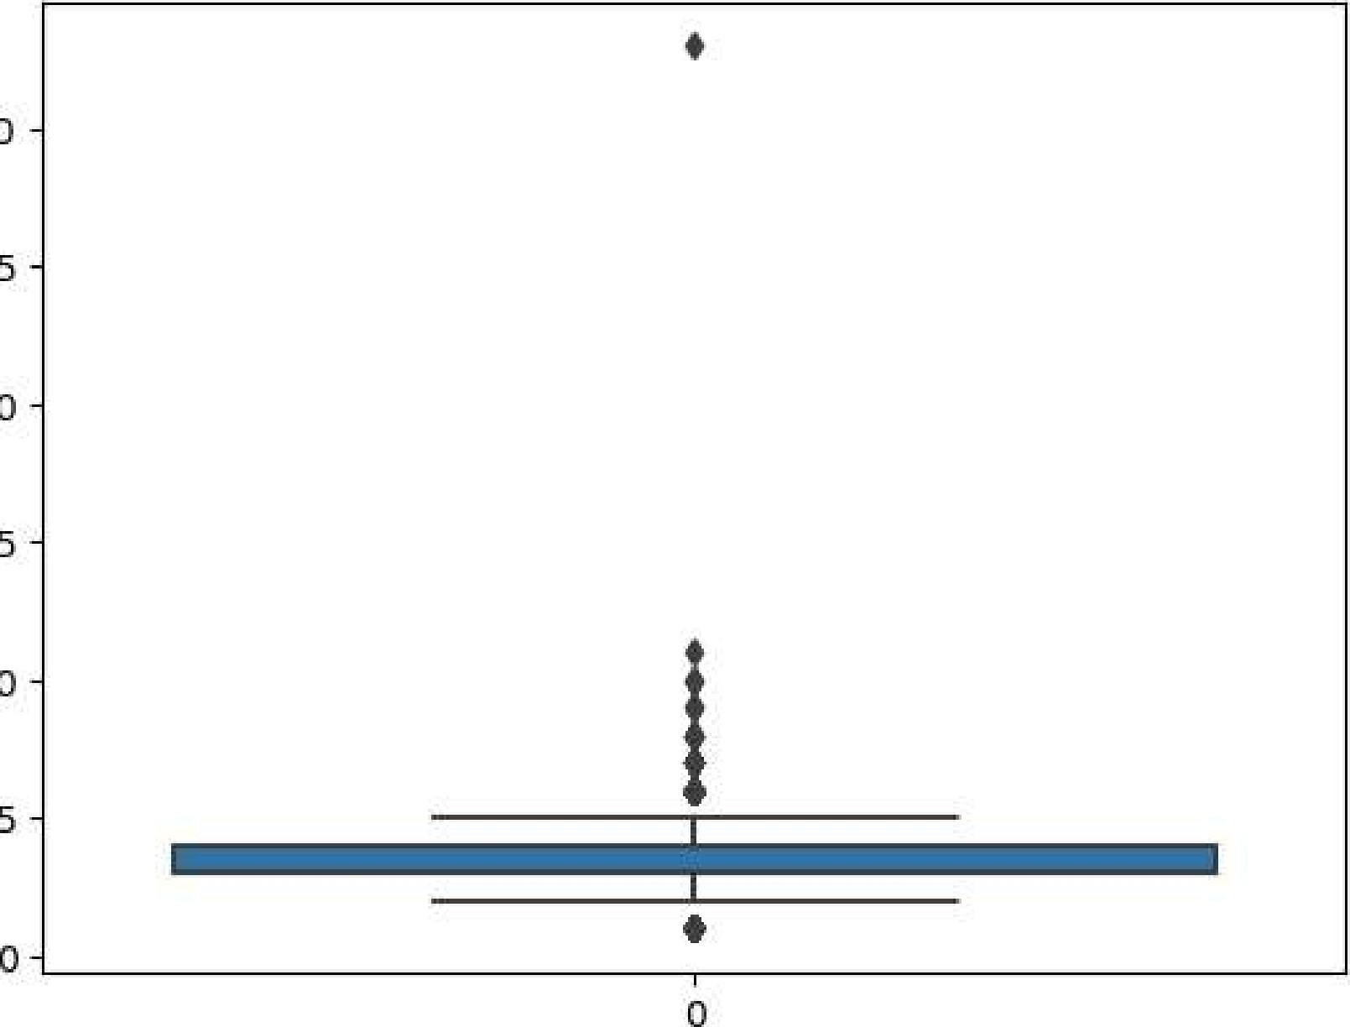30

25

20

15

10

In [13] :'number of bedrooms

[14] : threshold-3



(array([ 76, 243, 268, 275, 624, 785, 1512, 1519, 1553,

|  |  |  |  |  |  |  |  |
| --- | --- | --- | --- | --- | --- | --- | --- |
| 1706, | 2814, | 3109, | 3114, 3322, | 3532, | 3600, | 4207, | 4486, |
| 4658, |  | 6591, | 6596, 6730, | 6982, | 6998, | 7003, | 7454, |
| 8559, | 8650, | 9282, | 9629, 9810, | 9955, | 10168, | 10177, | 10676, |
| 10748, | 10916, | 10944, | 11247, 11441, | 11547 , | 11877, | 12273, | 13048, |
| 13444, | 13825, | 14220, | 14481]), ) 49 |  |  |  |  |

In [15] : print(np.where(z<-3))

(array([], dtype=int64), )

# There are 138 outliers in number of bedrooms as proved from the boxplot and the fact that there are observations whose z-score is beyond 3

In [16] :

In [17] : sns.boxplot(dfl[ 'number of bedrooms ' ] )

Out[17] : <AxesSubp10t : >

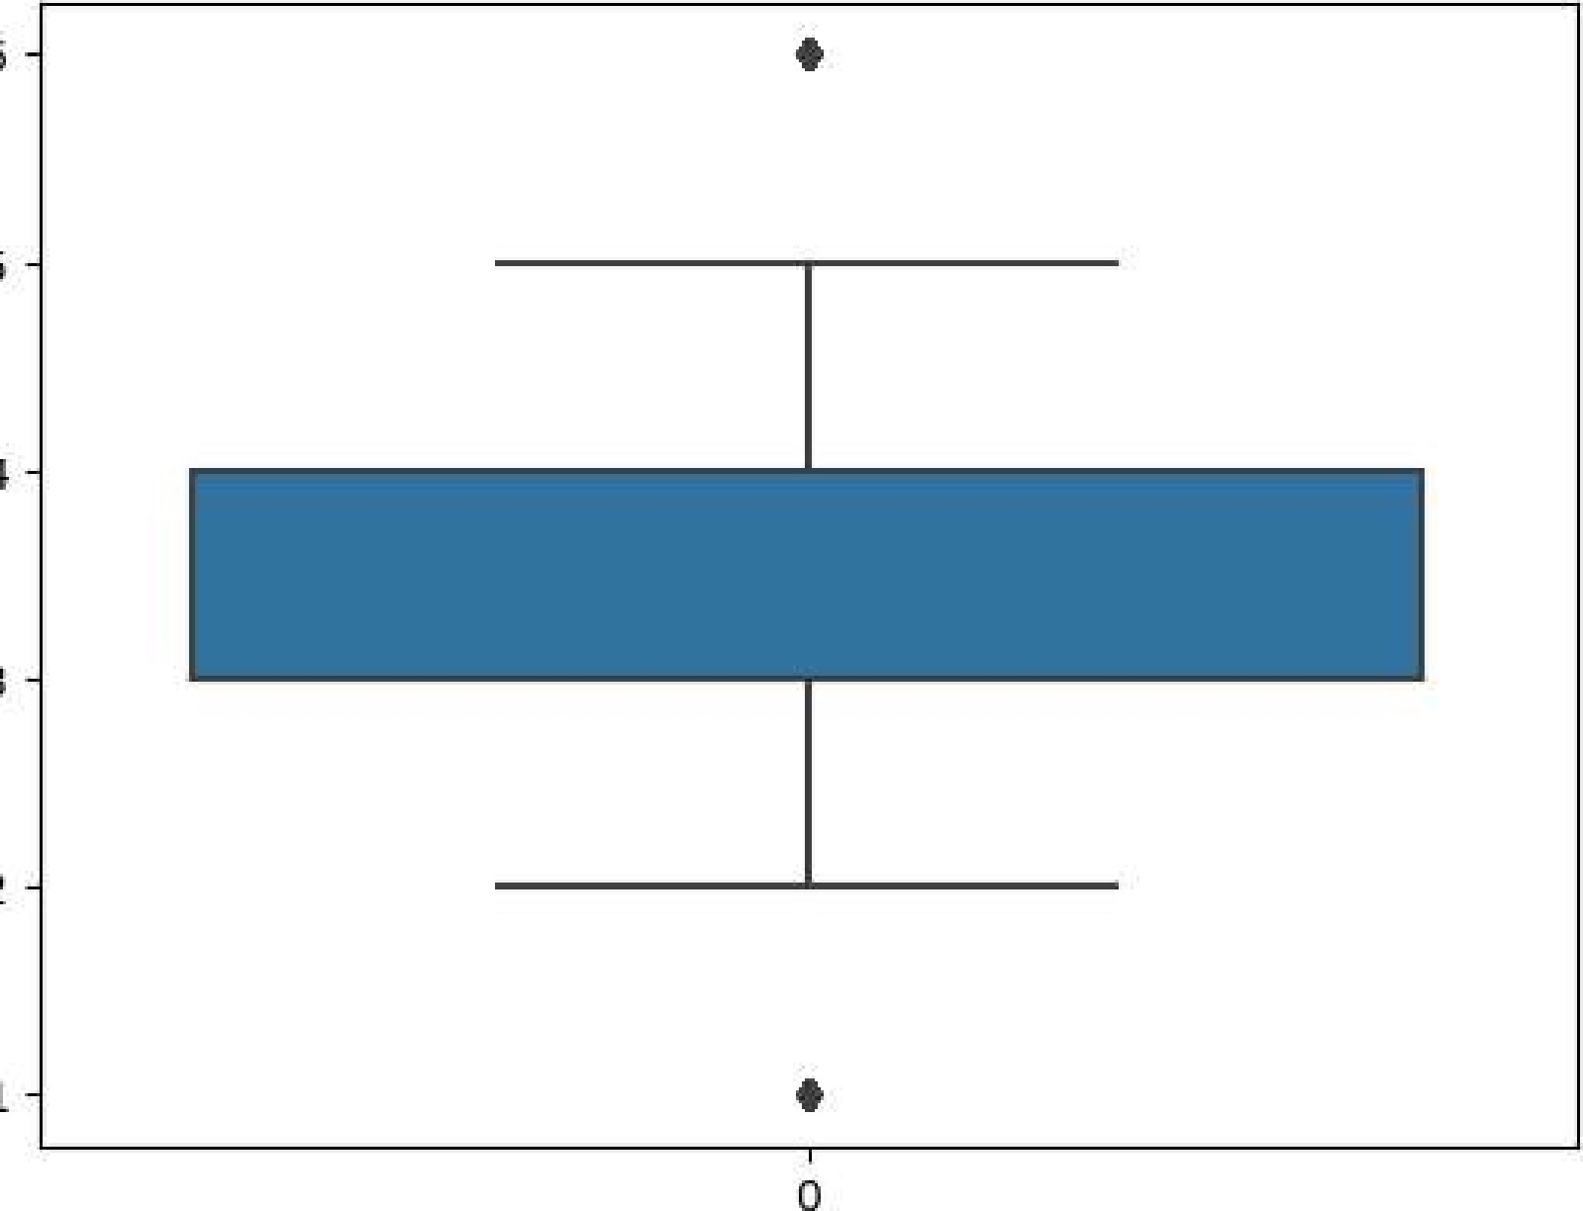6

5

4

3

2

1

## dfl

Out[18] :

number number number condition grade number of living lot waterfront Built Renovatio

id of of of of the of the bedrooms bathrooms area area floors present views house house Year Yee

o 6762810145 5 2.50 3650 9050 2.0 4 5 101921

1. 6762810635 4 2.50 2920 4000 1.5 5 81909
2. 6762810998 5 2.75 2910 9480 1.5 3 81939
3. 6762812605 4 2.50 3310 42998 2.0 3 92001
4. 6762812919 3 2.00 2710 4500 1.5 4 81929
5. 6762830250 2 1.50 1556 20000 1.0 4 71957
6. 6762830339 3 2.00 1680 7000 1.5 4 71968
7. 6762830618 2 1.00 1070 6120 1.0 3 61962
8. 6762830709 4 1.00 1030 6621 1.0 4 61955
9. 6762831463 3 1.00 900 4770 1.0 3 61969 200

14571 rows x 22 columns



In [ 19] : sns.boxplot(dfl[ 'number of bathrooms

Out[19] : <AxesSubp10t : >

8

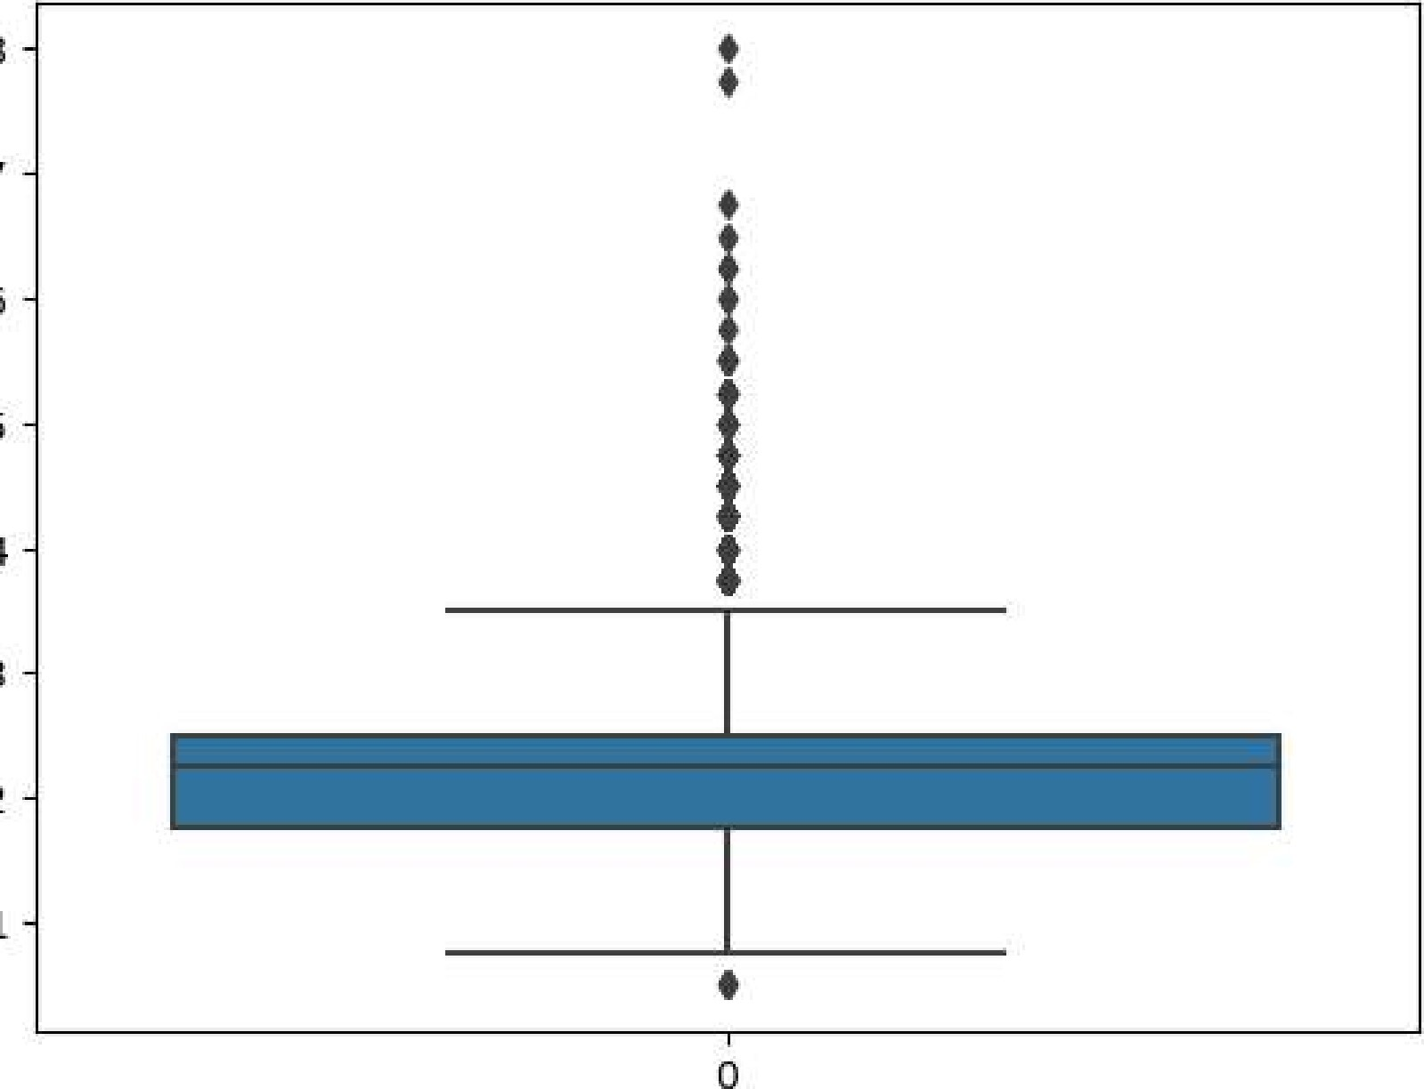7

6

5

4

3

2

1

In [20] :  'number of bathrooms' ] ) )

|  |  |
| --- | --- |
|  | len(np.where(z>3) [0] ) |
| Out[21] : | 124 |
| In [22] : | print(np.where(z<-3)) |

(array([], dtype=int64), )



I n [ 24 ] : sns.boxplot(dfl[ 'number of bathrooms' ] )

Out[24]

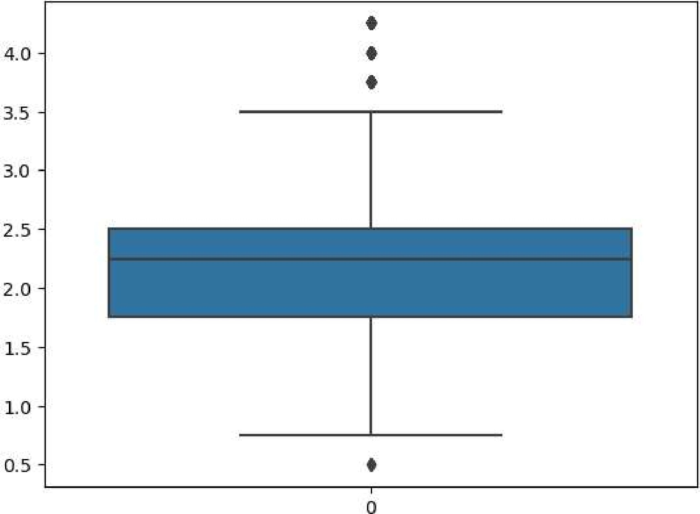

[25] : dfl

Out[25] :

number number number condition grade number of living lot waterfront Built Renovatio

id of of of of the of the bedrooms bathrooms area area present house house Year Yee floors views

o 6762810145 5 2.50 3650 9050 2.0 4 5 101921

* 1. 6762810635 4 2.50 2920 4000 1.5 5 81909
  2. 6762810998 5 2.75 2910 9480 1.5 3 81939
  3. 6762812605 4 2.50 3310 42998 2.0 3 92001
  4. 6762812919 3 2.00 2710 4500 1.5 4 81929

1. 6762830250 2 1.50 1556 20000 1.0 4 71957
2. 6762830339 3 2.00 1680 7000 1.5 4 71968
3. 6762830618 2 1.00 1070 6120 1.0 3 61962
4. 6762830709 4 1.00 1030 6621 1.0 4 61955
5. 6762831463 3 1.00 900 4770 1.0 3 61969 200

14447 rows x 22 columns



# There are 124 outliers in number of bathrooms as proved from the boxplot and the fact that there are observations whose z-score is beyond 3



Out [26]

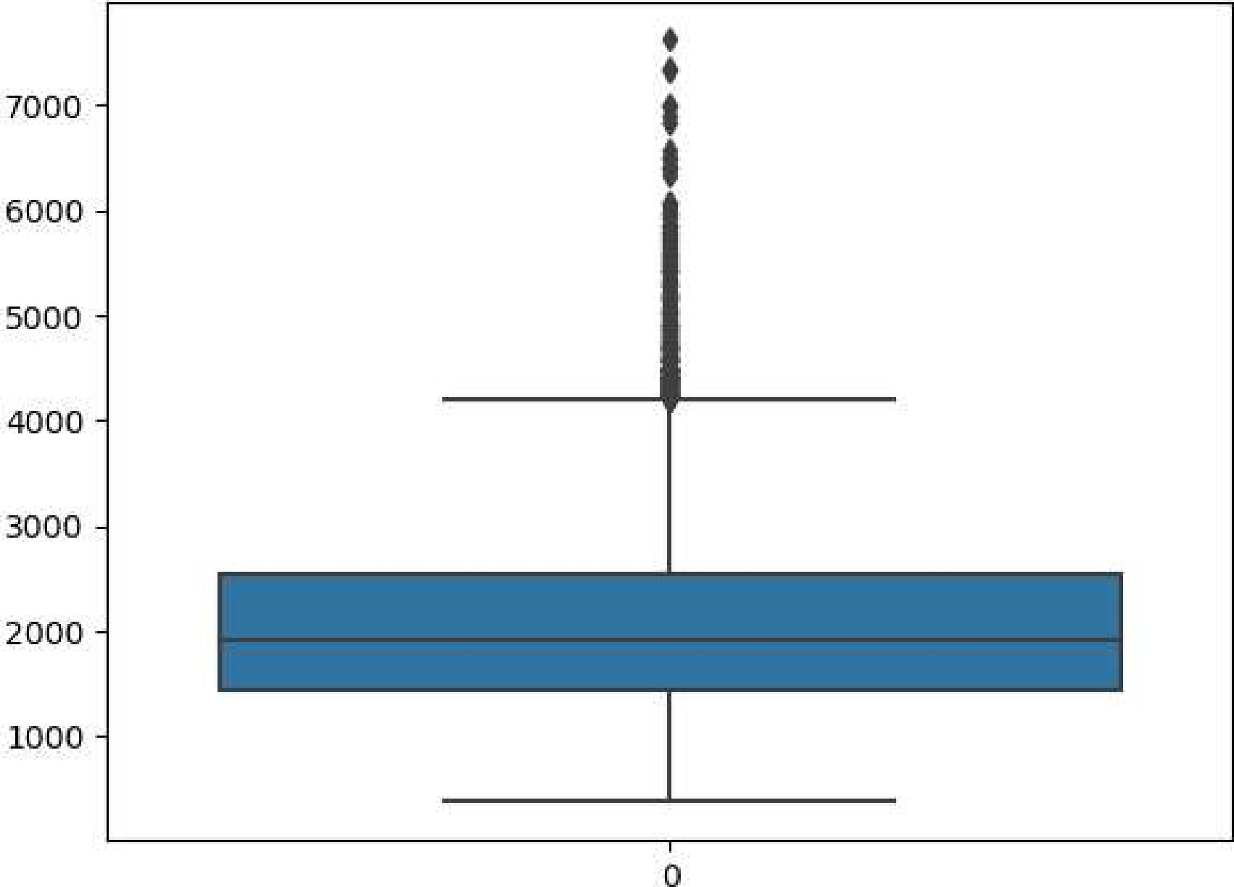

In [27] :' living area' ] ) )

In [28] : len(np.where(z>3) [0] )

Out[28] : 136

In [29] : len(np.where(z<-3) [e])

Out[29] : 

df1=df1[(z<3)]

In [31] :

Out[31]

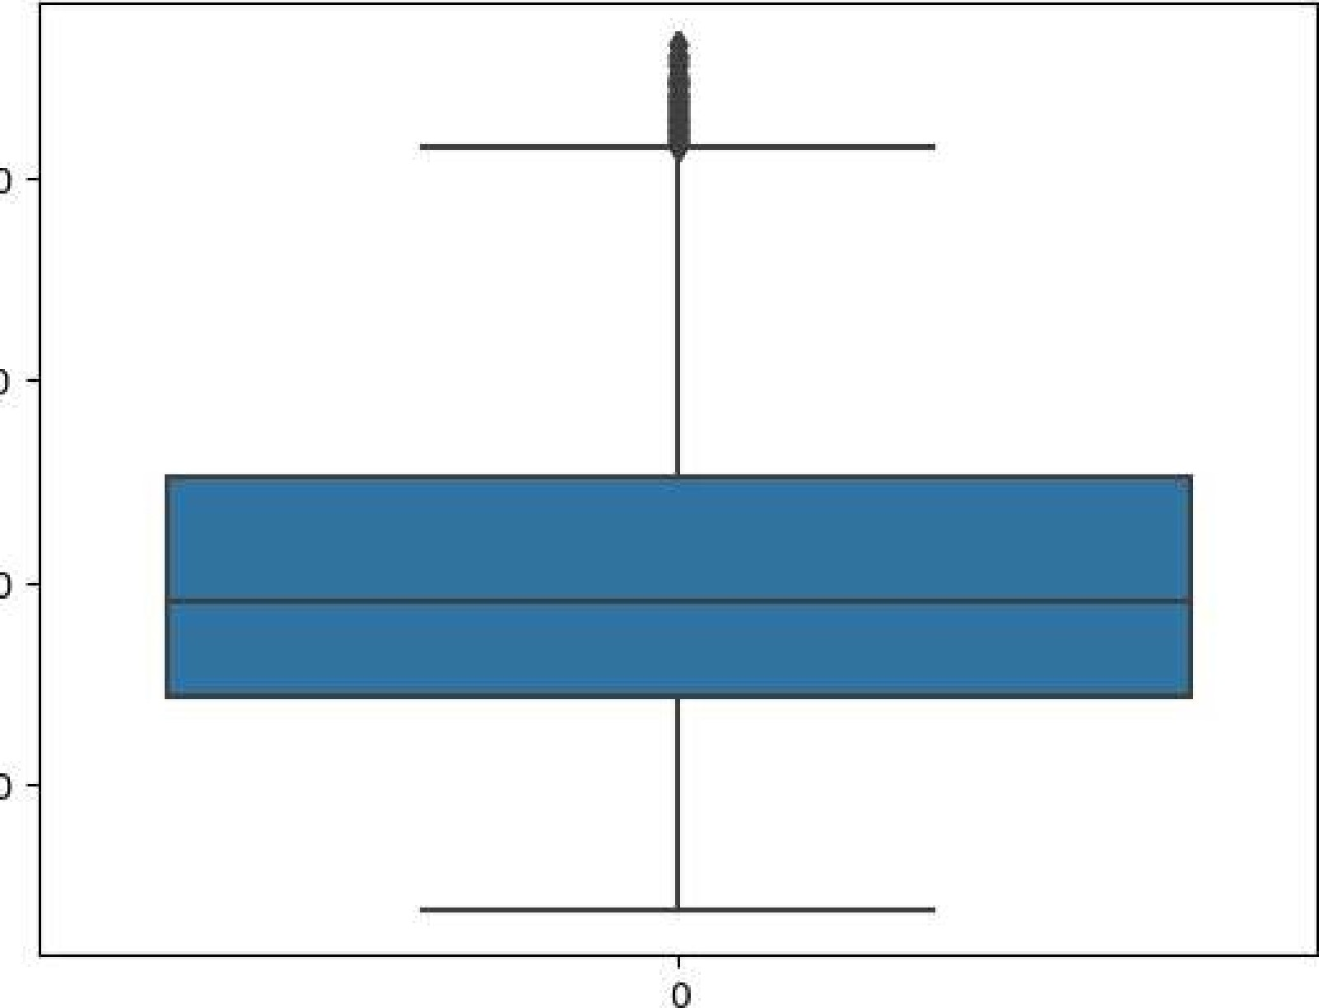4000

3000

2000

1000

|  |  |  |
| --- | --- | --- |
| In [32] : |  | ' living area' ] ) ) |
| In [33] : | len(np.where(z>3) [0] ) |  |
| Out[33] :  In [34] : | 67 |  |
| In [35] : | ' |  |

Out[35]

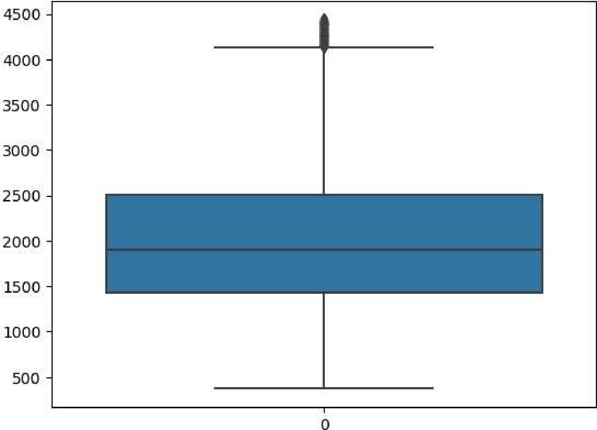

Ιη [ 36 ] : df1

Out[36] :

number number number condition grade number of living lot waterfront Built Renovatio

id of of of of the of the bedrooms bathrooms area area present house house Year Yee floors views

o 6762810145 5 2.50 3650 9050 2.0 4 5 101921

1. 6762810635 4 2.50 2920 4000 1.5 5 81909
2. 6762810998 5 2.75 2910 9480 1.5 3 81939
3. 6762812605 4 2.50 3310 42998 2.0 3 92001
4. 6762812919 3 2.00 2710 4500 1.5 4 81929
5. 6762830250 2 1.50 1556 20000 1.0 4 71957
6. 6762830339 3 2.00 1680 7000 1.5 4 71968
7. 6762830618 2 1.00 1070 6120 1.0 3 61962
8. 6762830709 4 1.00 1030 6621 1.0 4 61955
9. 6762831463 3 1.00 900 4770 1.0 3 61969 200

14244 rows x 22 columns



# There are 205 outliers in living as proved from the boxplot and the fact that there are observations whose z-score is beyond 3

In [37] : sns.boxplot(dfl[ 'number of floors' ] )

Out[37]

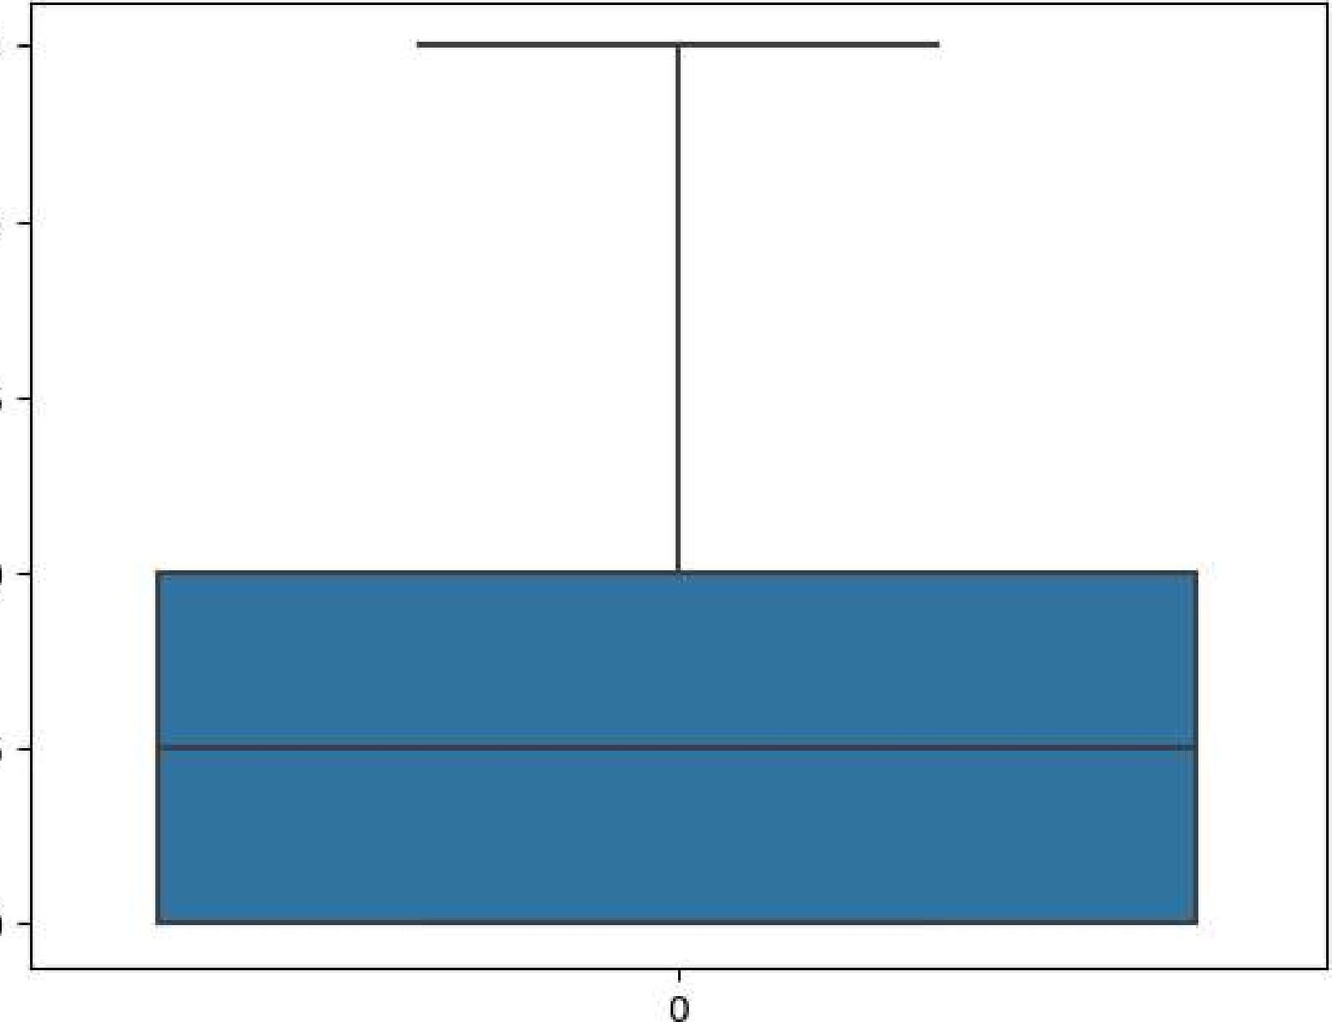3.5

3.0

2.5

2.0

1.5

1.0

|  |  |
| --- | --- |
| In [38] : | 'number of floors' ] ) ) |
| In [39] : | len(np.where(z>3) [0] ) |
| Out[39] :  In [40] : | 3    sns.boxplot(dfl[ 'number of floors' ] ) |
| Out[41] : | <AxesSubp10t : > |

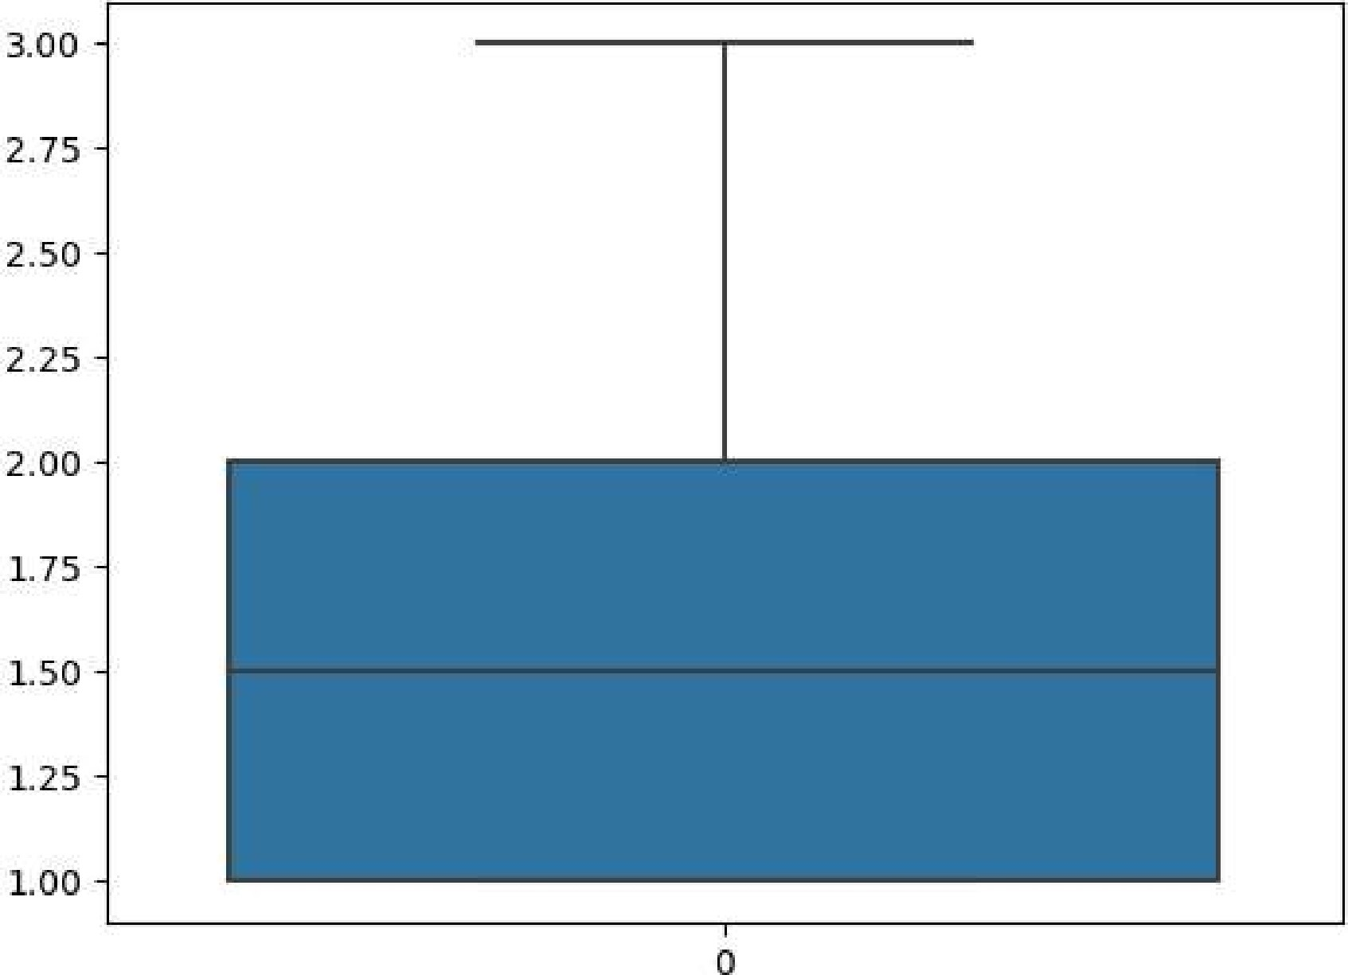

There are 3 outliers in number of floors

I n [ 42 : sns .

Out[42] : <AxesSubp10t : >

|  |  |
| --- | --- |
| In [43] :  In [44] : | z=np.               'Price' ] ) ) |
| Out[44] :  In [45] : | 259 |
| In [46] : | dfl |

le6

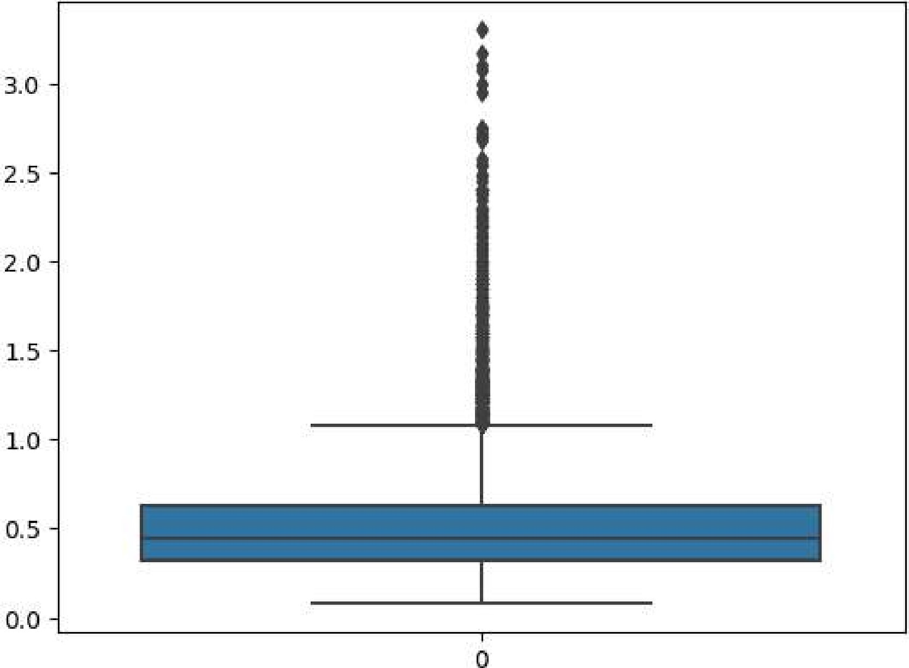

number number number condition grade number of living lot waterfront Built Renovatio

id of of of of the of the bedrooms bathrooms area area floors present views house house Year Yee

* 1. 6762810998 5 2.75 2910 9480 1.5 3 81939
  2. 6762812605 4 2.50 3310 42998 2.0 3 92001
  3. 6762812919 3 2.00 2710 4500 1.5 4 81929
  4. 6762813105 3 2.50 2600 4750 1.0 4 91951
  5. 6762813157 5 3.25 3660 11995 2.0 2 3 102006

1. 6762830250 2 1.50 1556 20000 1.0 4 71957
2. 6762830339 3 2.00 1680 7000 1.5 4 71968
3. 6762830618 2 1.00 1070 6120 1.0 3 61962
4. 6762830709 4 1.00 1030 6621 1.0 4 61955
5. 6762831463 3 1.00 900 4770 1.0 3 61969 200

13982 rows x 22 columns



In [47] : 

In [48] : dfl

number number number condition grade Area of number of living lot waterfront Built

id of of of of the of thethe bathrooms area area present Year bedrooms floors views house house basement

* 1. 6762810998 5 2.75 2910 9480 1.5 3 8o 1939
  2. 6762812605 4 2.50 3310 42998 2.0 3 9o 2001
  3. 6762812919 3 2.00 2710 4500 1.5 4 8830 1929
  4. 6762813105 3 2.50 2600 4750 1.0 4 9900 1951
  5. 6762813157 5 3.25 3660 11995 2.0 2 3 10o 2006

1. 6762830250 2 1.50 1556 20000 1.0 4 7o 1957
2. 6762830339 3 2.00 1680 7000 1.5 4 7o 1968
3. 6762830618 2 1.00 1070 6120 1.0 3 6o 1962
4. 6762830709 4 1.00 1030 6621 1.0 4 6o 1955
5. 6762831463 3 1.00 900 4770 1.0 3 6o 1969

13982 rows x 21 columns



Bl - VARIATE ANALYSIS

# The column Renovation year have been removed. This is because most of the Renovation Year are O and proves to be of no use to the model

In [49] : 

<AxesSubp10t:x1abe1='number of bedrooms ' ylabel= ' Price' >

600000

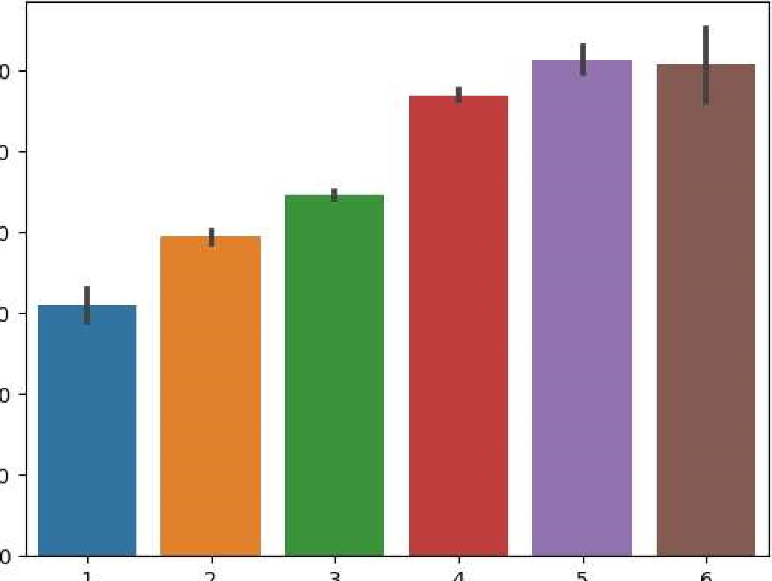

4

1

2

3

5

500000

400000

300000

200000

100000

6 number of bedrooms

# Clear indication of Price increasing with number of bedrooms



barplot

of

Out[50] :number of bathrooms' ,

le6

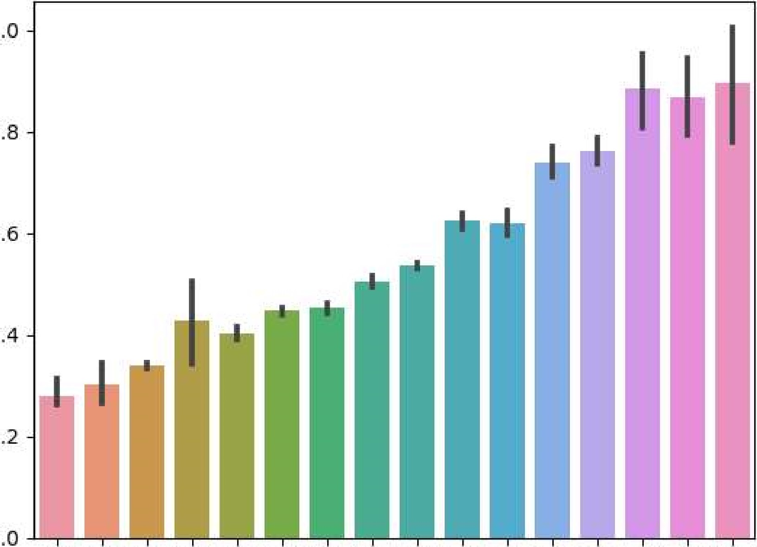

1.0

0.8

0.6

0.4

0.2

0.0

0.5 0.75 1.0 1.25 1.5 1.75 2.0 2.25 2.5 2.75 3.0 3.25 3.5 3.75 4.0 4.25 number of bathrooms

# Clear indication of Price increasing with number of bathrooms

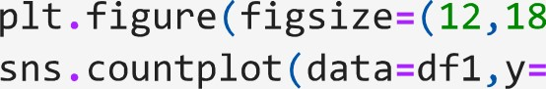In [51] : 18))

' Built Year' ) PI t . show()

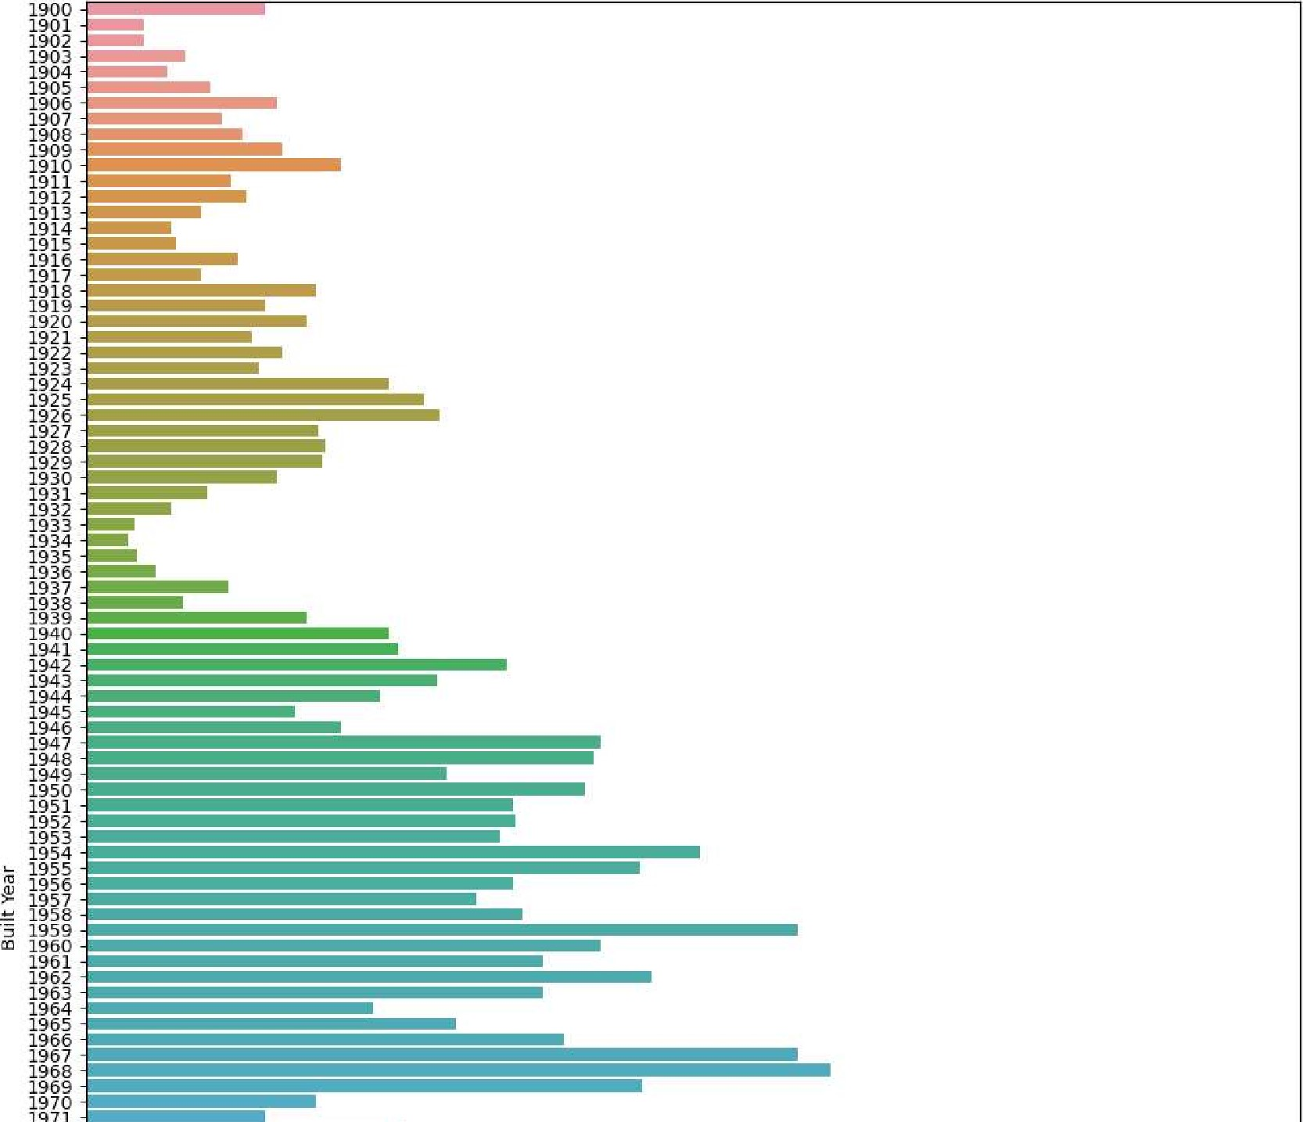

200 count

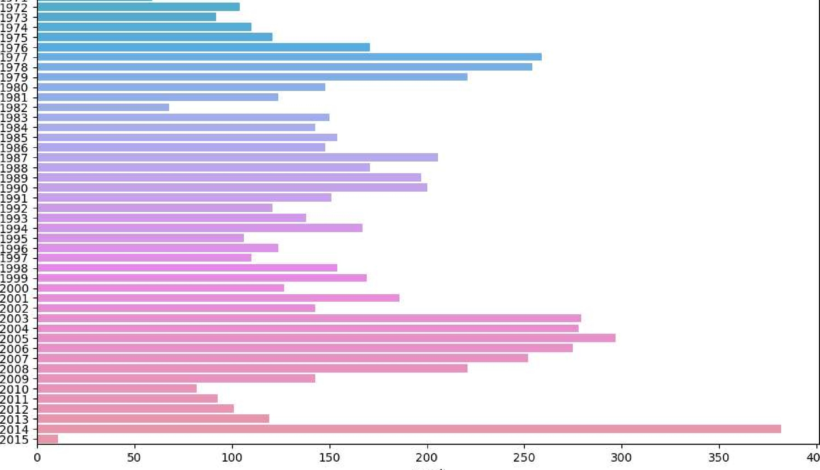

400

Most of the houses were listed for sale in 2017

ln [52] : plt.figure(figsize=(12,18) ) sns.countplot (data=dfl,y='Posta1 Code' ) Pl t . show()

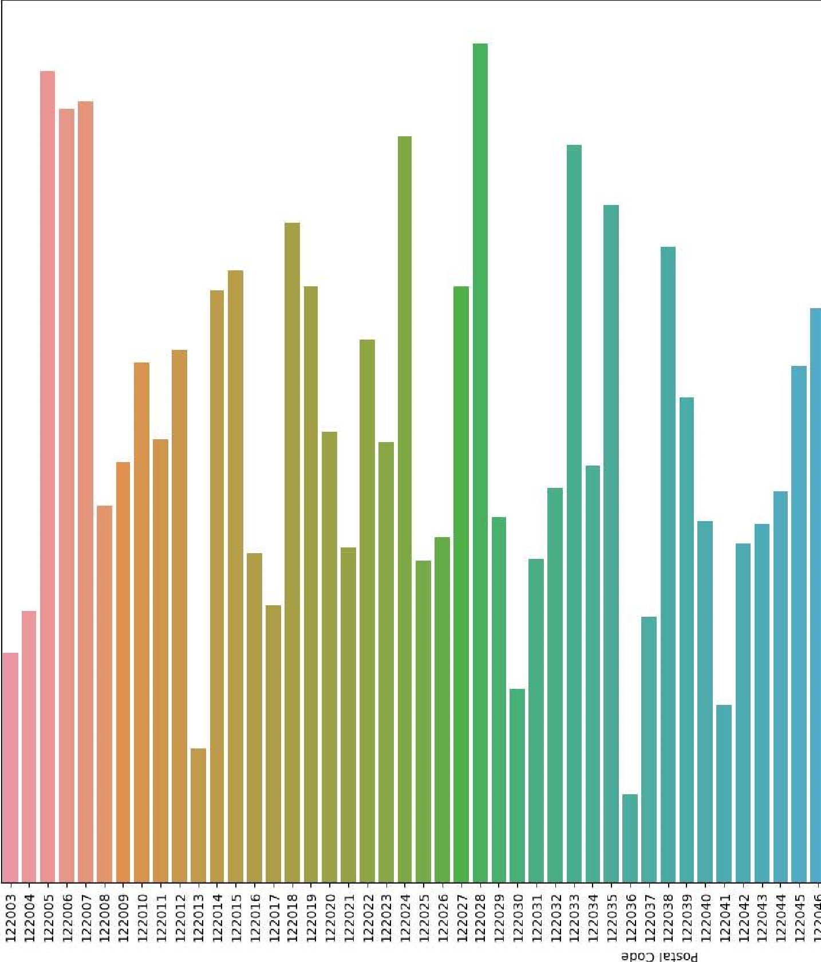

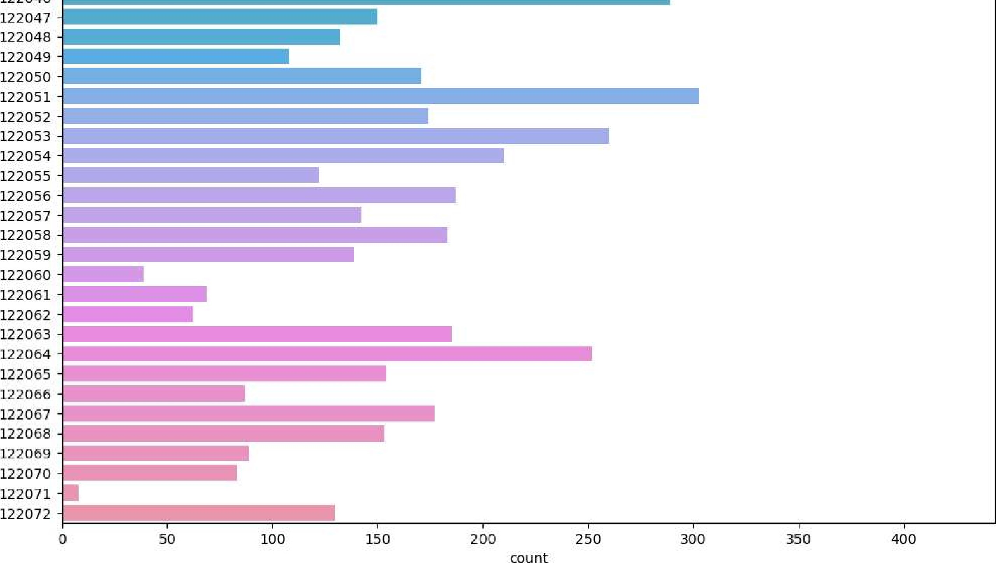

# Most of the houses listed for sale are from the Pincode 122028

|  |  |  |
| --- | --- | --- |
| In [53] : | Year | -2014] [ ' L attitude' ] . mean() |
| Out [53] : | 52.77583376963351 |  |

In [54] : 

-114.38898952879582

m = folium. Map(location [52.77, -114.4], tiles = 'OpenStreetMap' , zoom_start=8)

Out[55] : 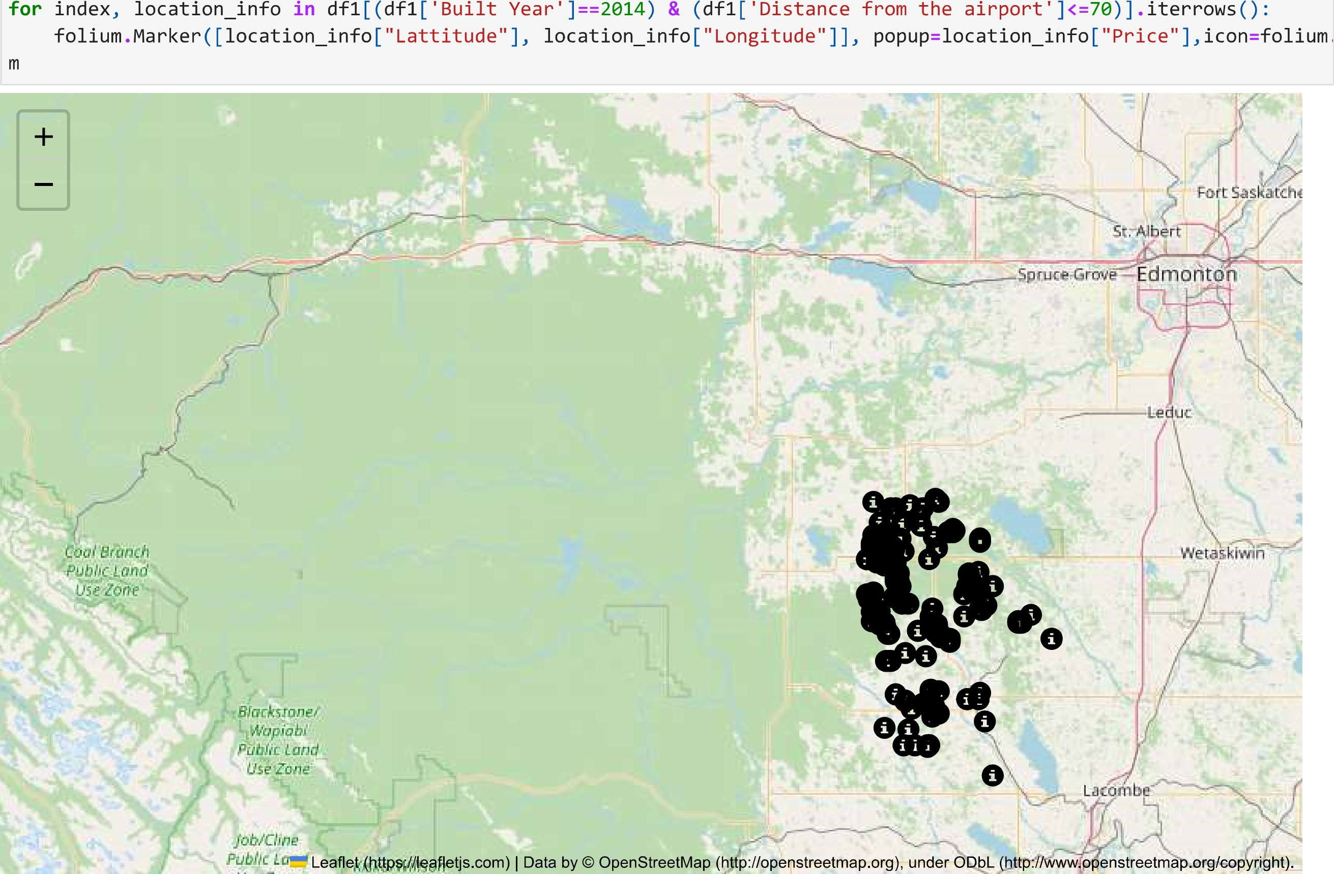

In [56] : 

52 .77850305343512

|  |  |
| --- | --- |
| In [57] :  Out[57] : | 'Built Year'  ' Longitude' ] . mean()  -114.39186768447837 |

folium. Map (location = [52.77, -114.4], tiles = 'OpenStreetMap' , zoom_start=8)

for index, location _info in df1[(df1[ 'Bui1t Year' ]>=2014) & (dfl[ 'Distance from the airport' folium.Marker([10cation_info["Lattitude"], location_info["Longitude"] ], m

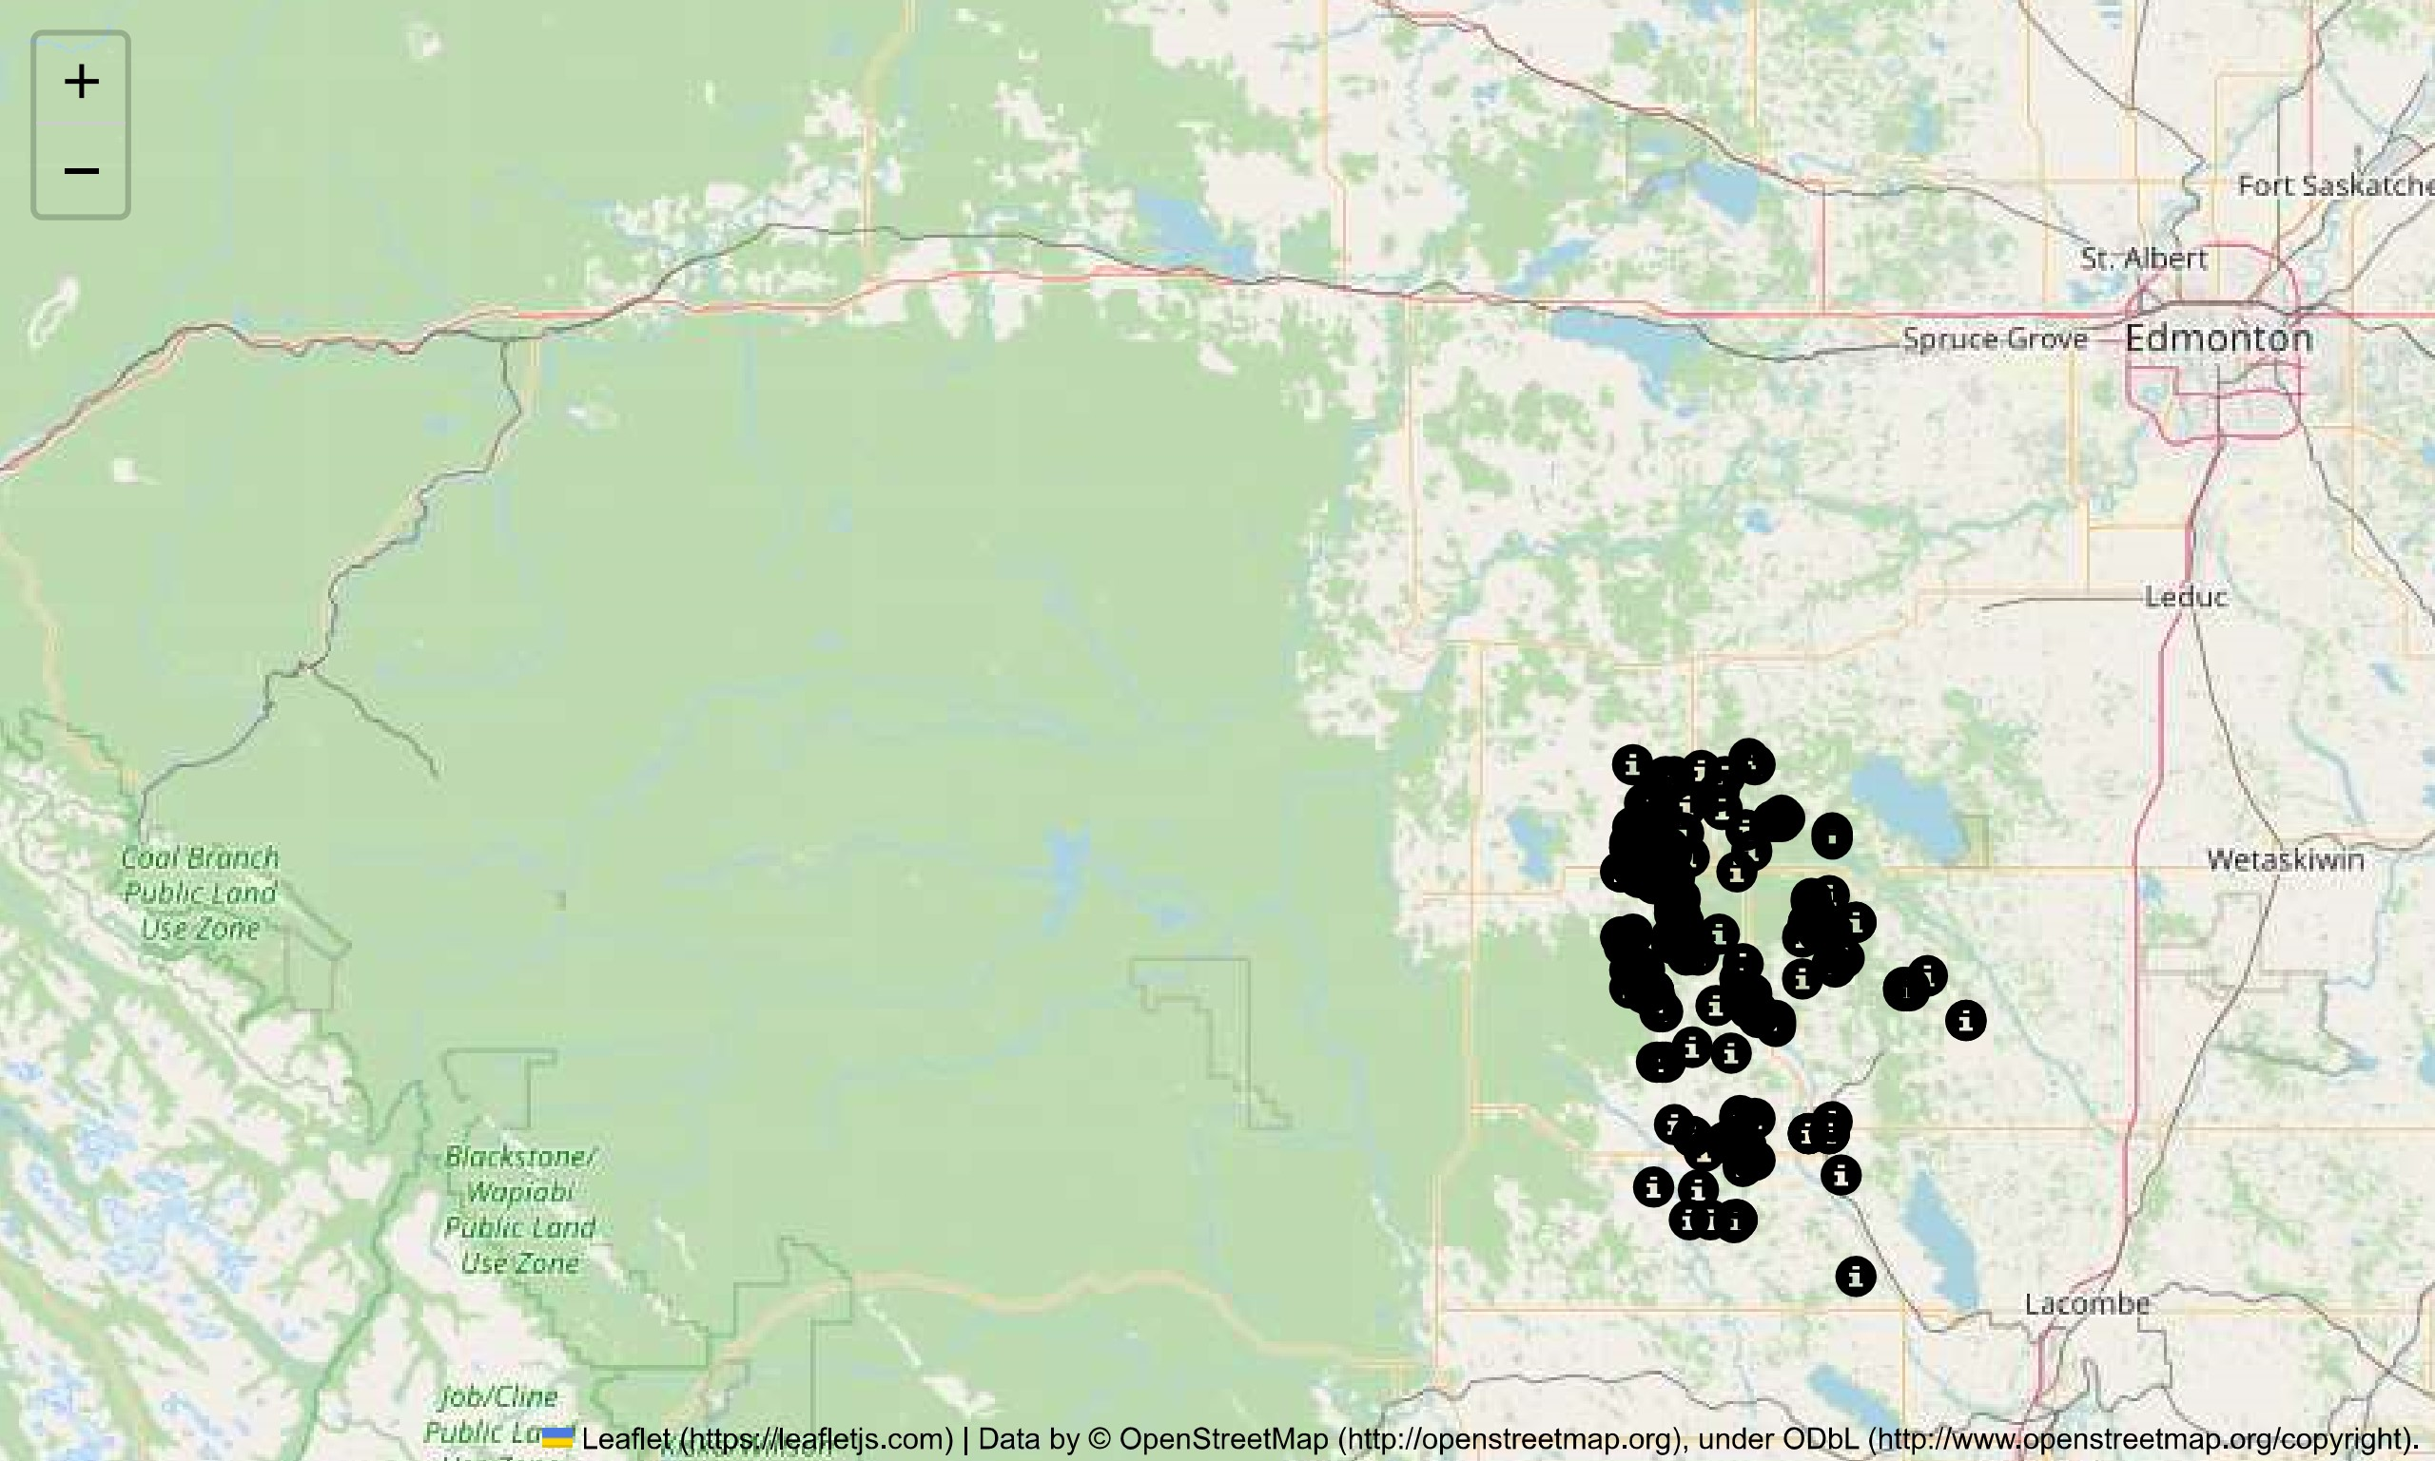

# The houses listed for sale in this dataset are located in Alberta, Canada



In [60] :  ' Postal Code' ],axis=l)

MULTI - VARIATE ANALYSIS

# Columns ID and Postal Code have been dropped from df as an increase or decrease in Postal Code shall not directly impact the Price of the property

In [61] : plt.figure(figsize=(15,15)) sns . heatmap(dfl . corr() , linewidths=0.5, annot=True, cmap= ' Blues ' ) PIt . show()

1.0

 number of bedrooms 0.023 '-0,035 0,041 01026 0.28 0.17 -0.036 0.15 0.016 0.0033-0.003

number of bathrooms 0.49 0.05 0.62 0.63 0.21 0.008 0.24 0.047 0.0017 0.011

liVing area 0.6 0.71 0.15 0.72 0.85 .36 0.34 0.16 0.00060.0055

0.8

o. 05 0.15 -0.014 0.031 0.075 -0.0047 0.087 0.16 -0.00240.042 -0.097 0.21 0.14 0.00890.0055 0.078

number of floors 0.16 -0,014 -0,011 40.023 0.28 -0.3 0,041 0.13 0.27 -0.023 -0,007 0,017 0.2

waterfront present•-O.035 -0.004 0.011 0.03i -0.011 01019-0.00460.0038 0.02? -0.039 -0.047 -0.0" 0.02 0.038 -0.01 -0.0086 0.090.6

number of views - 0.041 0-1 0.18 0.075 -0.023 0.046 0.16 0,067 0.22 -0.072-0.027 -O.OB9 0.21 0.067 0.0027-0.0058 0.2

condition of the house - 0.02& -0.13 -0.071-0.0047 -0.23 0,019 0,046 -0.17 -0.19 0.2 -0.38 -0.0051 -0.12

0.4 grade of the house 0.34 0.62 0.72 0.004& o.lí -0.17 0.72 0.07 0.1 o. 093 -0.00140.0078

Area of the house(excluding basement) 0116 0,0038 0,067 -0.19 -0.18 -0,031 0.17 -0.00370.0067

Area of the basement .28 0.21 .0024 -0.3 0,027 0.22 0.2 0.07 -0.18 -0.17 0.1L -0.17 '0.11 -0.011 0.0077-0.0016, 0.2

0.2

Built year 0.17 0.042 *0.039 -0.38 0.47 0.46 0.06+0.00038000410.047

Lattitude -90.036 0.008 0028 -0,097 0.041 -0,047 0.1 -0.031 0.11 -0.15 -0.13 0.028 -0.1 O.OL6 0.0078

Longitude 0.15 0.24 0.28 0.21 0.13 0069 -0.089 -0.12 0.22 0.39 0.41 0.25 -0.00911000420.04

0.0

livi 0.39 0.53 0.74 0.68 0.72 0,028 0,17 -0.007-0.001

IOt area renov -0.016 0.047 0.16 -0.023 0,038 0,067-0.000670.093 0.17 -0,011 0.063 -0.1 0.25 0.17 -0.023 -0.012 0.065

|  |  |  |  |
| --- | --- | --- | --- |
| Number ot schools nearbY -0.00330.00170.00058).0089-0.007 | -0.01 |  | 0.023 -000100026 |
| Distance from the airport -0.0033 0.011 0.00550.0055 0.017 |  |  | 0.0051 |
| Price 0.07B 0.27 | 0.091 00.28 | 0.053 | 0.065 0.00260.0051 |

5' 0.2S o. 047 0.049

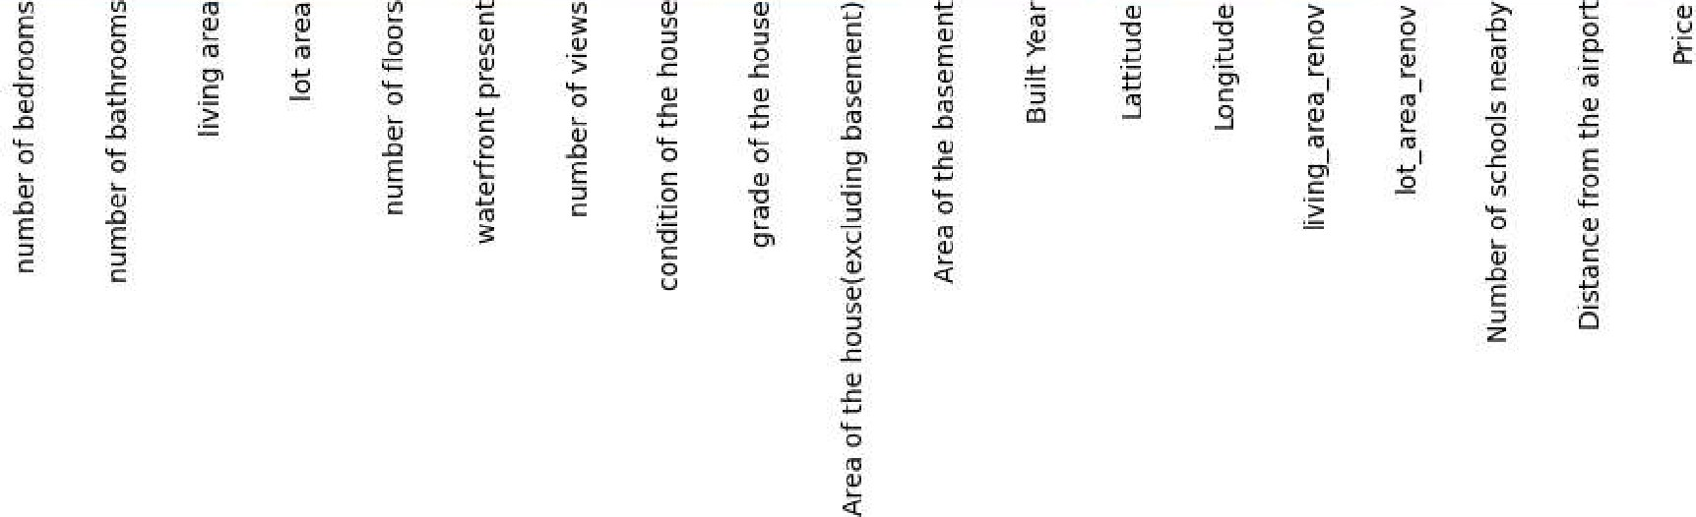

Columns like 'lot area','condition of the house','BuiIt Year','Iot_area_renov','Number of schools nearby','Distance from the airport','Longitude' contribute minimal to Price which is the Target variable. Hence it is removed before training

In [62] :  'lot area' , ' condition of the house' , ' Built Year' , 'lot area renov' , 'Number of schools nearby' , 'Distance

In [63] : plt.figure(figsize=(15,15) ) sns .heatmap(dfl . corr() , linewidths=0.5, annot=True, cmap= ' Blues ' ) PIt . show()

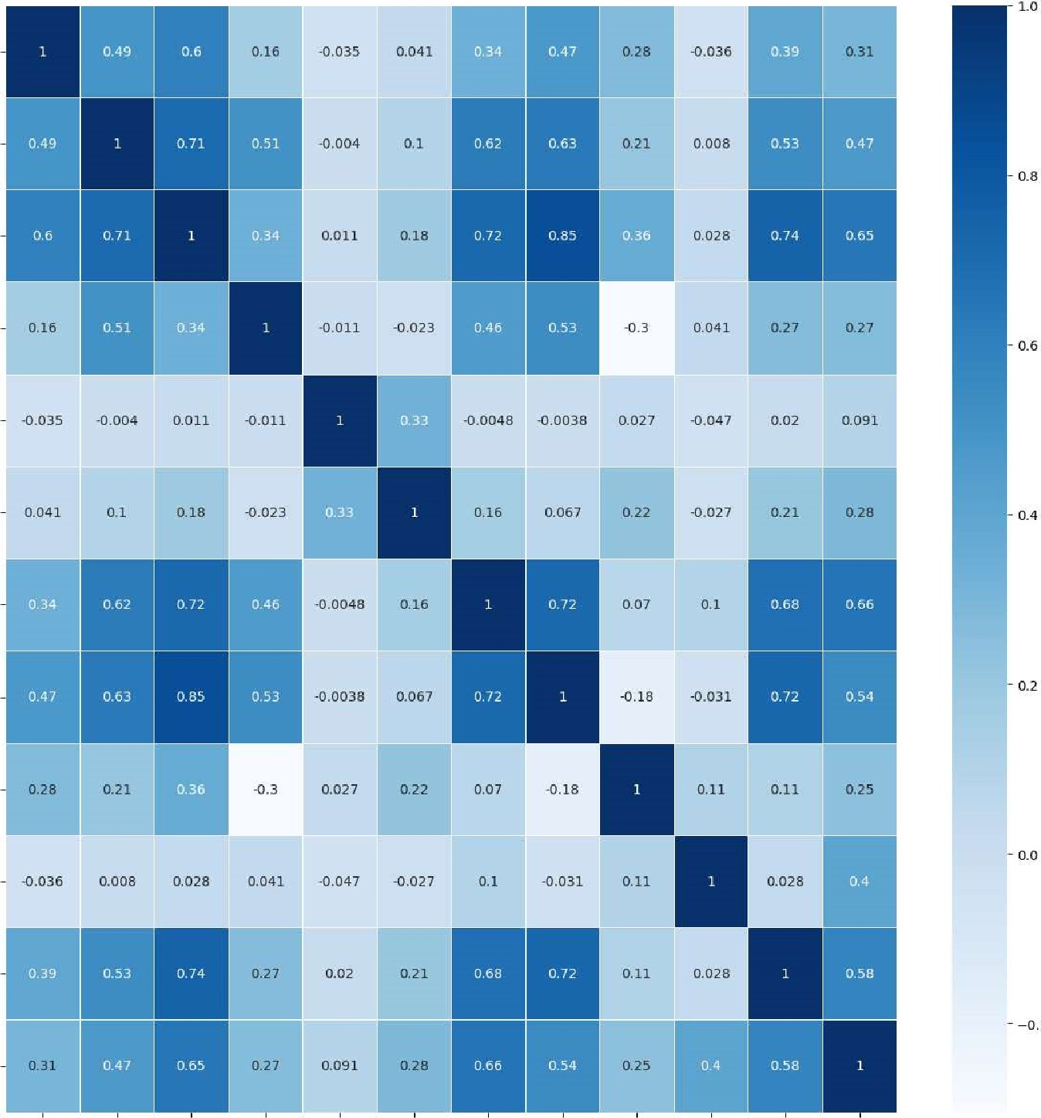

1.0

number

of

bedrooms

number

of

bathrooms

living

area

number

of

floors

watertront

present

number

ot

views

grade

of

the

house

Area

of

the

house(excluding

basement)

Area

of

the

basement

Lattitude

living_area

renov

Price

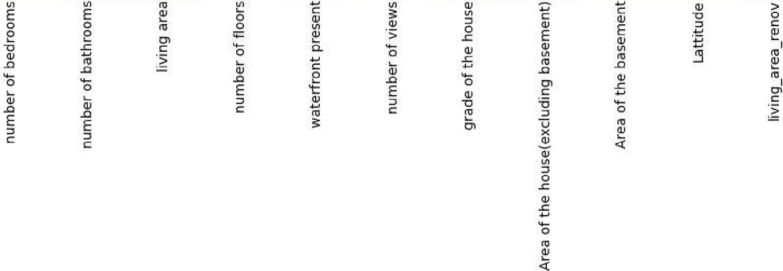

Training of Model, Splitting of Dataset into Train and Test Set

|  |  |
| --- | --- |
| In [64] : | from sklearn . model_selection import train_test_split |
| In [65] : | X=df1.drop( [ ' Price' ],axis =1) |

In [66] : X. shape

|  |  |  |
| --- | --- | --- |
| Out[66] : | (13982, 11) |  |
| In [67] : | ' Price ' ] |  |
| In [68] : | y. shape |  |
| Out[68] : | (13982, ) |  |
| In [69] : | X_train, X_test, y_train, | train_test_split (X, y, test_size=0.2, random_state=ll) |
| In [70] : | X_train . shape |  |
| Out[70] : | (11185, 11) |  |
| In [71] : | X_test . shape |  |

|  |  |
| --- | --- |
| Out[71] : | (2797, 11)  from sklearn.pipeline import make_pipeline from sklearn.preprocessing import StandardSca1er from sklearn.linear_model import ElasticNet, Lasso, LinearRegression, RidgeCV from catboost import CatBoostRegressor from sklearn.ensemble import RandomForestRegressor, GradientBoostingRegressor f rom xgboost import XGBRegressor from sklearn.tree import DecisionTreeRegressor from sklearn.ensemble import StackingRegressor from sklearn.svm import SVR |
| In [73] :  In [74] : | pipelines  en' :make_pipe1ine(StandardSca1er(), ElasticNet()),  ' lasso' :make_pipe1ine(StandardSca1er(), Lasso())'  'Rcv l :make_pipe1ine(StandardSca1er(), RidgeCV()),  'CatB' : make_ pipeline(StandardSca1er(), CatBoostRegressor(eva1_metr1c• ='RMSE ' ,verbose-1000) ) ,  ' Ir ' :make_pipe1ine(StandardSca1er(), LinearRegression()),  ' rf' :make_pipe1ine(StandardSca1er(), RandomForestRegressor()),  'gb' :make_pipe1ine(StandardSca1er(), GradientBoostingRegressor()), ' dtc (StandardSca1er() , DecisionTreeRegressor()), xg' :make_pipe1ine(StandardSca1er() ,XGBRegressor()) |

for algo, pipeline in pipelines. items() :

model pipeline.fit(X_train, y_train) fit_models[algo] - model

/opt/conda/1ib/python3.7/site-packages/sk1earn/1inear_mode1/_coordinate_descent.py:648: ConvergenceWarning: Objective did not converge. You might want to increase the number of iterations, check the scale of the features or consider inc reasing regularisation. Duality gap: 4.781e+12, tolerance: 5.929e+1e coef 11_ reg, 12_ reg, X, y, max_iter, tol, rng, random, positive Learning rate set to 0.05996 e: learn: 221490.1496581 total: 61.4ms remaining: 1m Is

999: learn: 77595.2298921 total: 2.85s remaining: eus

from sklearn . metrics import mean_absolute_error, mean_ squared _error

for algo, model in fit_models.items() :

Yhat model . predict (X_test) al . append (algo) maes . append (mean_squared_error (y_test , yhat) * *0.5) print(algo, 'MEAN ABSOLUTE ERROR' , (y_test, yhat) ) print(algo, 'ROOT MEAN SQUARED ERROR' ,mean_squared_error(y_test,yhat)**0.5)

en MEAN ABSOLUTE ERROR 104444.32355671145 en ROOT MEAN SQUARED ERROR 140011.53917862213 lasso MEAN ABSOLUTE ERROR 97479.23118789196 lasso ROOT MEAN SQUARED ERROR 132916.1566456281 Rcv MEAN ABSOLUTE ERROR 97481.91673717603

Rcv ROOT MEAN SQUARED ERROR 132918.333682342

CatB MEAN ABSOLUTE ERROR 66637.30790160663

CatB ROOT MEAN SQUARED ERROR 97508.34029611414 Ir MEAN ABSOLUTE ERROR 97574.48622571728 Ir ROOT MEAN SQUARED ERROR 132952.7515959945 rf MEAN ABSOLUTE ERROR 69217.89879907611 rf ROOT MEAN SQUARED ERROR 102292.3632979867 gb MEAN ABSOLUTE ERROR 69874.84067217445 gb ROOT MEAN SQUARED ERROR 101056.41447857216 dtc MEAN ABSOLUTE ERROR 96944.72285782386 dtc ROOT MEAN SQUARED ERROR 143316.21683052482 xg MEAN ABSOLUTE ERROR 69035.05210660976 xg ROOT MEAN SQUARED ERROR 100694.41040458805

In [76] : plt.figure(figsize=(5, 5)) plt.xlabel( 'ML Algorithms. . . I ) plt.ylabel( 'Root Mean Squared Errors. ' ) ax=sns . barplot (x=al, y=maes) PI t . show()

140000

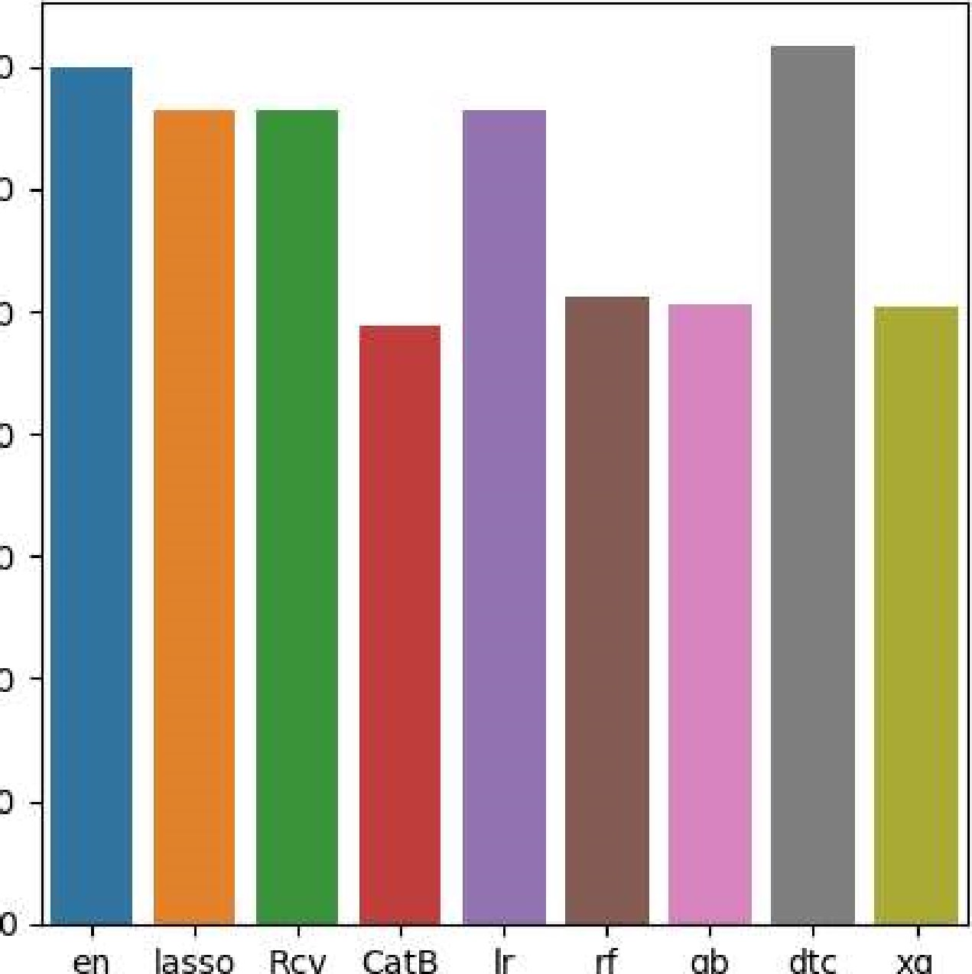

en

lasso

RCV

Cata

Ir

gb

dtc

xg

120000

2 100000

LLI

 80000

 60000

40000

200001

ML Algorithmsv..

|  |  |  |
| --- | --- | --- |
|  | |  | | --- | | CatB  ' RMSE ' ) rf = RandomForestRegressor() gb = GradientBoostingRegressor() xg = XGBRegressor()  1r=LinearRegression()  stregr - StackingRegressor(estimators=[( 'catb' ,CatB), ( 'xg' , final_estimator=lr)  pipeline - make_pipeline( StandardSca1er(), stregr  pipeline. fit (X_train, y_train) | |

# Generate predictions on the test set y_pred pipeline. predict (X_test)

# Evaluate the model print( " Root Mean Squared Error: %.4f" % mean_squared_error(y_test,y_pred)**0.5)

|  |  |  |  |  |  |
| --- | --- | --- | --- | --- | --- |
| Learning rate | set to 0.05996 |  |  |  |  |
| e : learn : | 221490. 1496581 | total : | 4.18ms | remaining: | 4.18s |
| 999: learn :  Learning rate | 77595.2298921 set to 0.057883 | total : | 2.81s | remaining: | eus |
| e: learn: | 222091.4863333 | total : | 3. 52ms | remaining: | 3. 51s |
| 999 : learn :  Learning rate | 76337 . 1933964 set to 0.057883 | total : | 2.52s | remaining: | eus |
| e : learn : | 222546. 8538661 | total : | 2 .94ms | remaining: | 2. 94s |
| 999 : learn :  Learning rate | 75466. 5961681 set to 0.057883 | total : | 2. 51s | remaining: | eus |
| e : learn : | 223455 . 5230951 | total : | 3.2ms | remaining: | 3.2s |
| 999: learn :  Learning rate | 75656. 3661258 set to 0.057883 | total : | 2.52s | remaining: | eus |
| e: learn : | 221606.9467960 | total : | 3.71ms | remaining: | 3.7s |
| 999: learn :  Learning rate | 75195 .9699196 set to 0.057883 | total : | 2.46s | remaining: | eus |
| e: learn : | 219316.0911020 | total : | 2.47ms | remaining: | 2.47s |

mean_ squared _error (y_test , y_pred) .5

al . append( stacked model' ) maes . append (mean_squared_error (y_test, y_pred) * *0.5)

for i in range(10) :

print("The RMSE of" , al [ i ] , ' is ' ,maes[i] )

plt.figure(figsize=(9,5)) plt.xlabel( 'ML Algorithms . . .

plt.ylabel( ' Root Mean Squared Errors . ' ) ax=sns . barplot (x=al, y=maes) PI t . show()

ALL DONE BY RESHMA J AS NAAN MUDALVAN IBM SMARTINTERNZ ASSIGNMENT 3